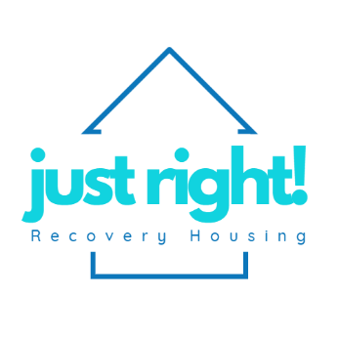**New Client Application**

Name:_________________________________________ Date:_______________

Current Address:____________________________________________________

Phone:_______________________ Email:________________________________

DOB:_____________________ Sex:__________ Marital Status:______________

Occupation:___________________________ SSN (Last 4):______________________

Religion/Spiritual Status:______________________________________________

Drug(s) of Choice:___________________________________________________

__________________________________________________________________

Legal Status (Probation, Parole, Deferred Adjudication, Felon): ______________

__________________________________________________________________

How many days/months/years do you have in continuous sobriety? ____________

__________________________________________________________________

Do you have any family or a support system? (List them all) ____________________

__________________________________________________________________

__________________________________________________________________

How did you hear about us? ___________________________________________

__________________________________________________________________

1. Why are you seeking a sober living house at this time?

_________________________________________________________________________________________________________________________________________________________________________________________________________________________________________________________________________________________________________________

1. How do you believe Just Right Recovery Housing can help you?

_________________________________________________________________________________________________________________________________________________________________________________________________________________________________________________________________________________________________________________

1. What are your 3 top priorities that you expect to gain from your sober living experience?

_________________________________________________________________________________________________________________________________________________________________________________________________________________________________________________________________________________________________________________

1. How long do you plan to live in the house?

____________________________________________________________________________________________________________________________________________________________________________________________________________________________________________________

Circle a number for each section based on your current emotional status.

Circle 1 if it does not apply.

Circle a number for each section based on your current recovery status.

Circle 1 if it does not apply.



MH Score Total:______________ DC Score Total: ______________

**For the following questions, please circle Yes or No.**

Are you currently working a 12-Step program? Yes No

Do you have a Sponsor? Yes No

Are you currently seeing a Therapist/Counselor? Yes No

Do you want to see a Therapist/Counselor? Yes No

Are you currently involved in a church or religious group? Yes No

Are you interested in working with a Life Coach? Yes No

Are you interested in working with a Recovery Coach? Yes No

Are you currently employed? Yes No

Are you currently enrolled in college/trade school? Yes No

Do you have a vehicle or other means of transportation? Yes No

Are you currently receiving SSI (Supplemental Security Income)? Yes No

Are you currently on food stamps? Yes No

Do you have any other forms of income? Yes No

If yes, what other forms of income do you have? ___________________________

______________________________________________________________________________________________________________________________________________________________________________________________________

Applicant Signature: __________________________________ Date:_________